Thomas Muir Primary School
Guidance to support learning and wellbeing during temporary lockdown

Family Wellbeing
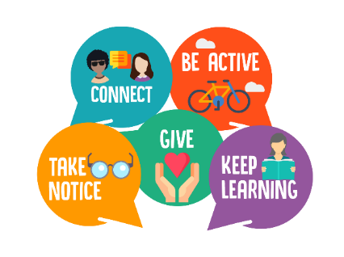

January 2021
Dear Thomas Muir Families
As you are aware, schools across East Dunbartonshire and beyond are closing temporarily to contain the spread of the coronavirus. We understand that this places huge demands on families at this time as you have many different challenges to balance, including childcare arrangements, remote learning and supporting family members who may be more vulnerable to the virus.
Family Wellbeing
At TMPS, we want to support you through this challenging time and therefore we would like to offer some tips for supporting remote learning at this time.
It is important for you to stay calm and resilient to help your child/children cope with the current circumstances. It is vital to maintain structure and routine for your child during the period of lockdown. The following tips will help you to maintain the balance of family life, wellbeing and learning.
Tips for Supporting Remote Learning
Each family has completely different circumstances and through our remote learning provision, we have tried to provide you with flexibility to support this at home.
Below are some tips that may be of use during this period:
- Limited devices? If you have limited devices in your home, review the learning set by your child’s teacher on a Friday and create a timetable for your device(s) for the following week.
- Remember not all activities need to be completed online. If your child prefers to complete work on paper, this is absolutely fine and a photograph of work can be shared via Teams. Decide when and for how long your child will have access to electronic devices and for what purpose.
- Are you finding that uploading your child’s work is time consuming? Do not feel that you have to upload everything your child does as we know that this can be time consuming for you. Prioritise the three assignments set by your child’s class teacher as this is what they will provide formative feedback on.
- Little and often. Remote learning is a difficult situation for you and for your child. You may find that they will engage more if they complete their tasks in chunks throughout the day rather than sitting for long periods of time.
- Play, Exercise, Relax. These are a really important part of child’s day too and can be a good way to chunk learning into shorter sessions.
- It’s ok if you’re finding it challenging to get your child to engage. Remote learning is a completely different scenario to school, especially if you are also working from home. Tasks are available for your child to complete at any point throughout the week to allow for flexibility in these situations. If you need support, contact the school and we will help you during this time.
- Make time for each other. Although everyone’s circumstances are different, make time for you as a family away from devices. This is important to make sure you have time to recharge.
- Stay connected with family and friends. Maintain contact with family and friends through technology such as face time.
- Stay connected with the TMPS community. There will be a new tab on the school website called 'Remote Learning' where you will find the latest updates. A weekly Sway newsletter will be sent home to families to keep you updates on what has been happening each week and to provide links to resources you may find useful. Remember to follow us on Twitter (@ThomasMuirPS) where we will post updates throughout the coming week.

We wish all our families the best of health and look forward to welcoming you back to school in due course.

Kind regards

Annamarie McIntosh

