
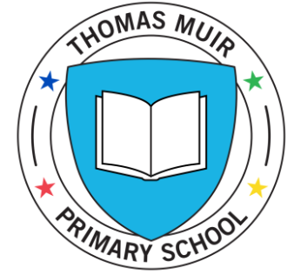

THOMAS MUIR PRIMARY SCHOOL
Kirriemuir Road
Bishopbriggs
Glasgow
G64 1DL

Email: office@thomasmuir.e-dunbarton.sch.uk

Tel: 0141 955 2290

8 January 2021

Dear Thomas Muir Families

Firstly, I would like to wish you all a healthy and happy new year.
Following on from the First Minister’s recent announcement, we are now living in a temporary lockdown across Scotland. This means that the majority of children will access remote learning from home and the children of key workers and vulnerable children will access learning in school.
This week, we have been making plans to deliver this service model. Over the course of today and Monday, you will receive the following communications from the school:
- Guidance to support learning and wellbeing during temporary lockdown
- Guidance – What learning and teaching will look like at TMPS
- East Dunbartonshire Council protocol for pupils and parents in the provision of digital learning as part of remote learning
In addition to the above, we will also re-issue an updated user guide for Microsoft Teams.

I will be meeting with our parent council on Monday 11 January to share information and to hear more about how the school can support families at this time.

If you have any questions or queries about learning on Microsoft Teams, please telephone the school or email the office. Class Teams pages are for communication about learning between teachers and pupils only.

Please stay connected during this time. Get in touch if there is anything we can help you with.

Kind regards

Annamarie McIntosh

Head Teacher

